1. pwd: it will show the present working directory of a user.

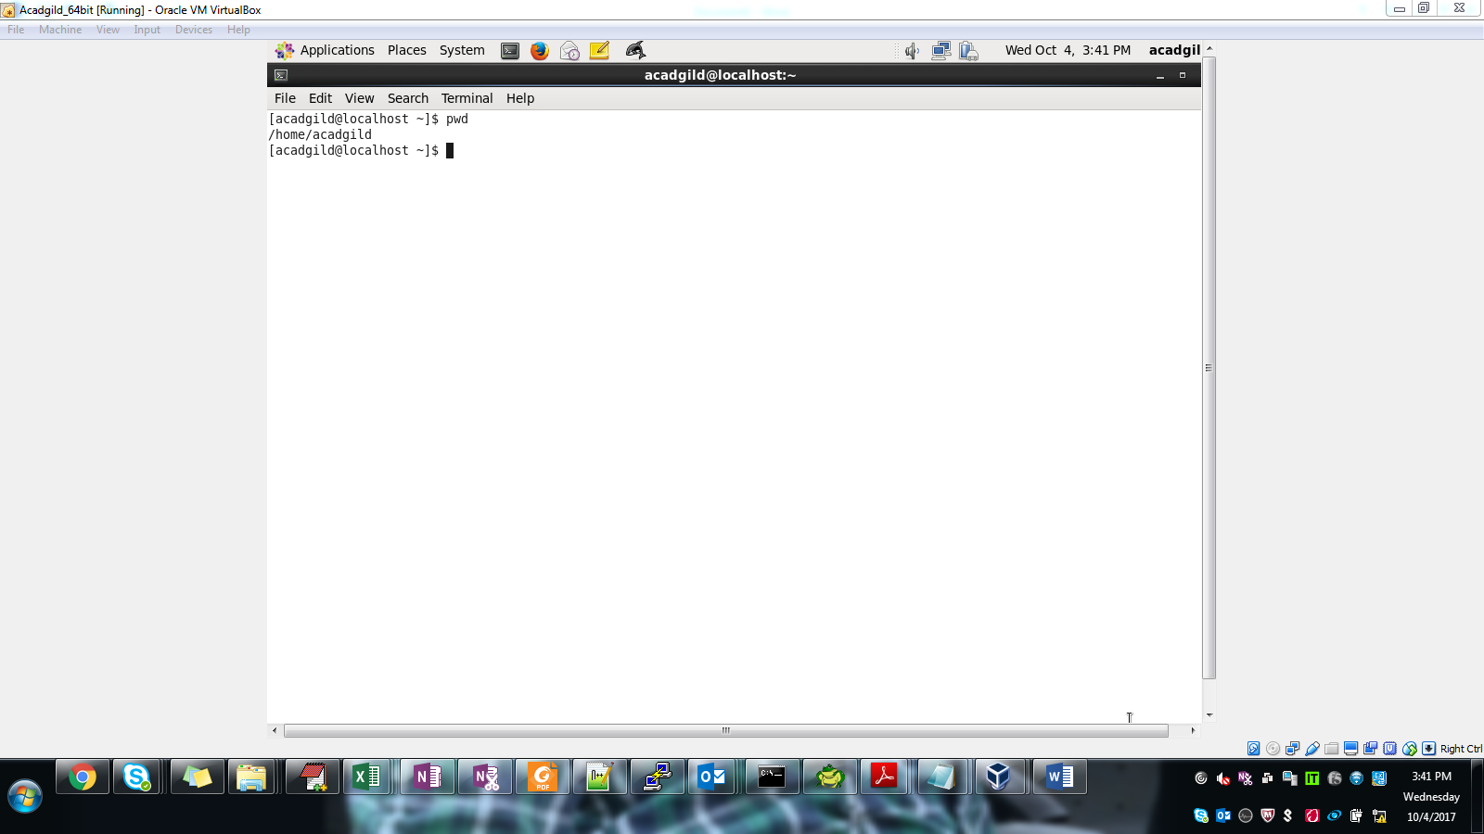

1. vi : will create new file to edit if this file is not present. If file is present simply it will open this for editing.

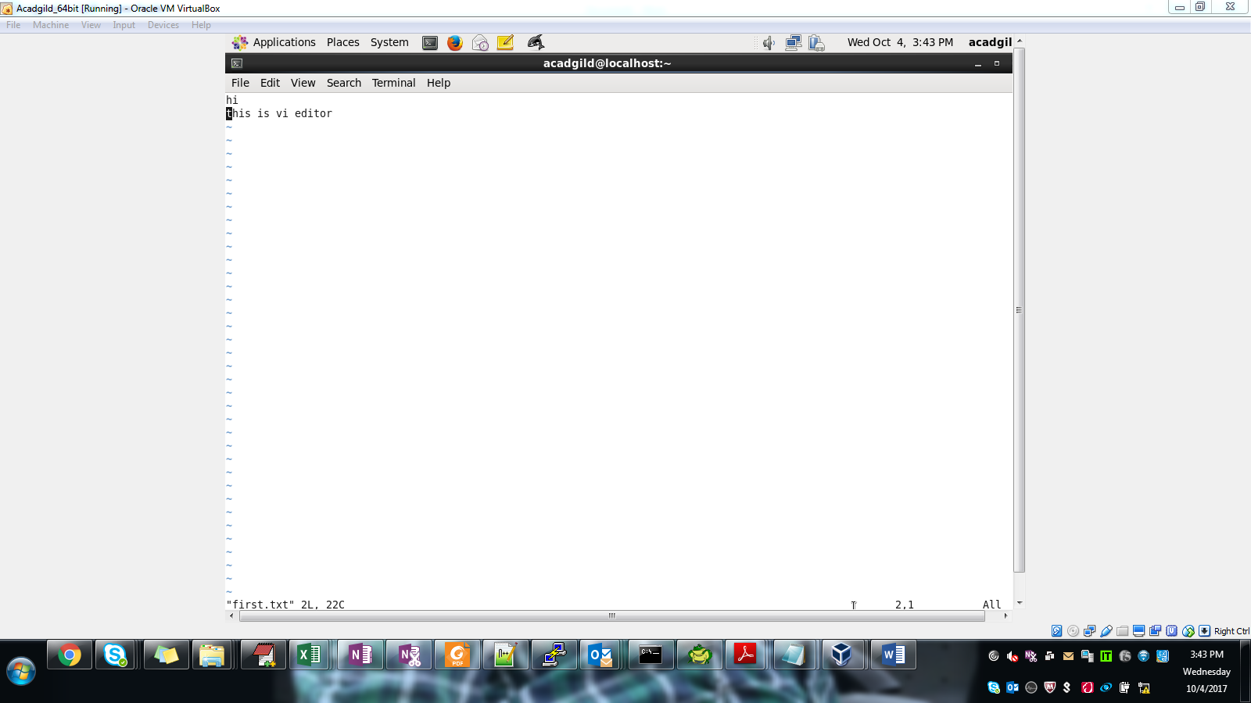

1. touch : will create empty file . we can edit this file later.

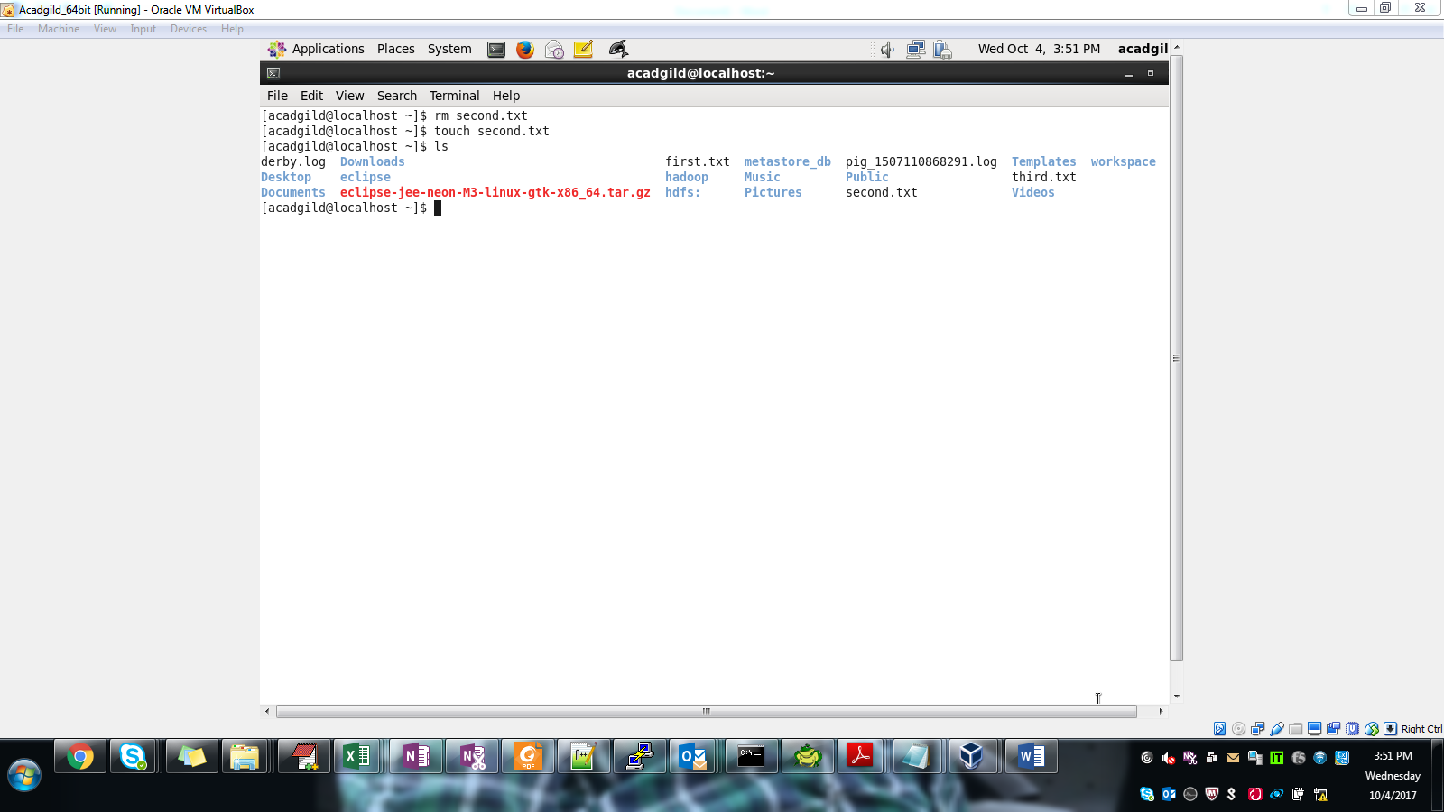

1. mkdir: will create new directory

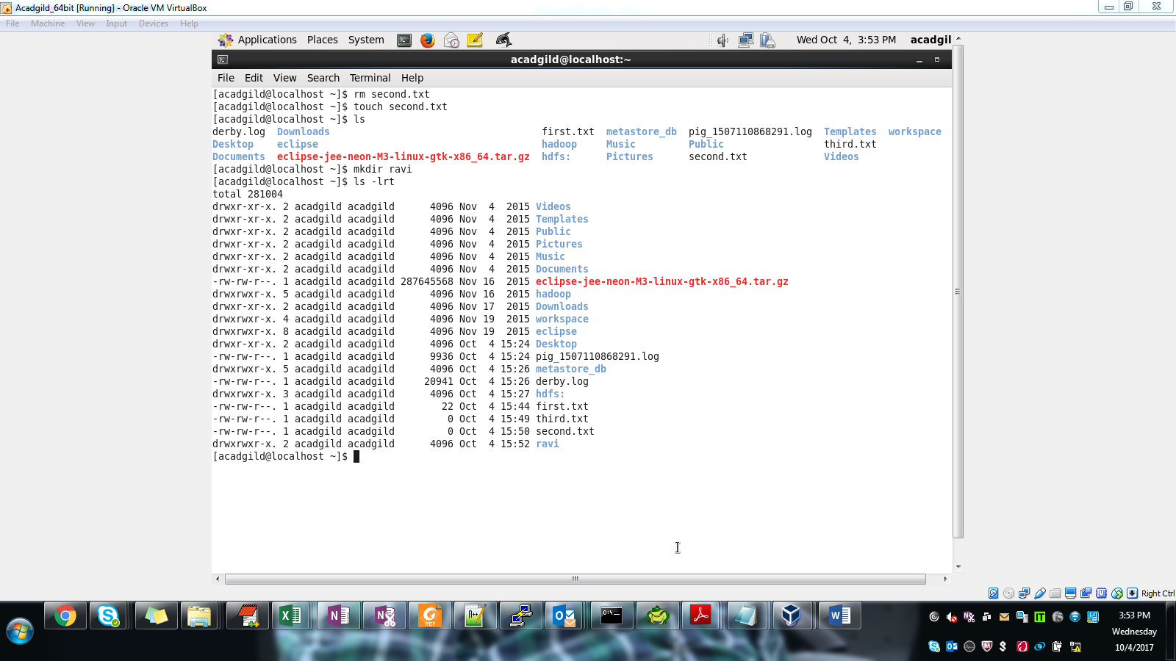

1. rm : will remove a file

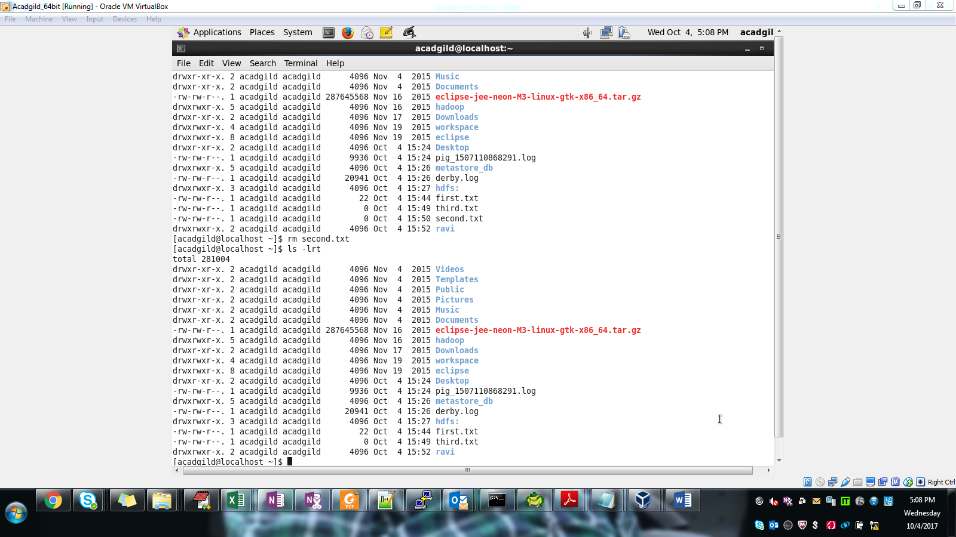

1. ls : to list the contents of a directory.

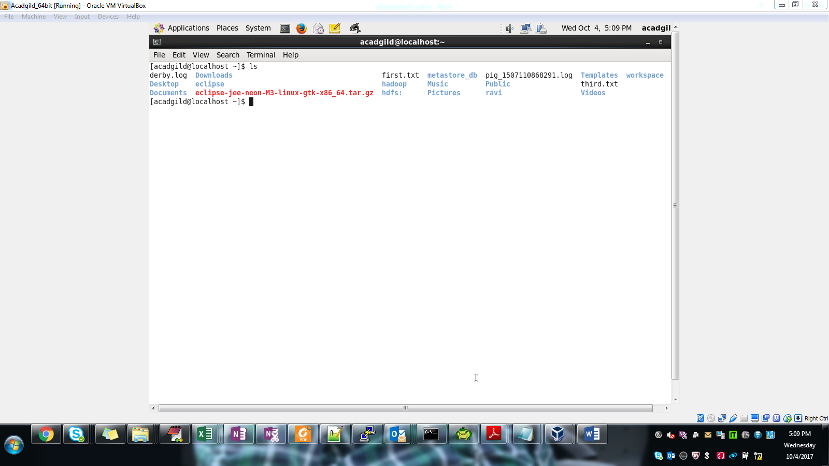

1. echo: display a line od text

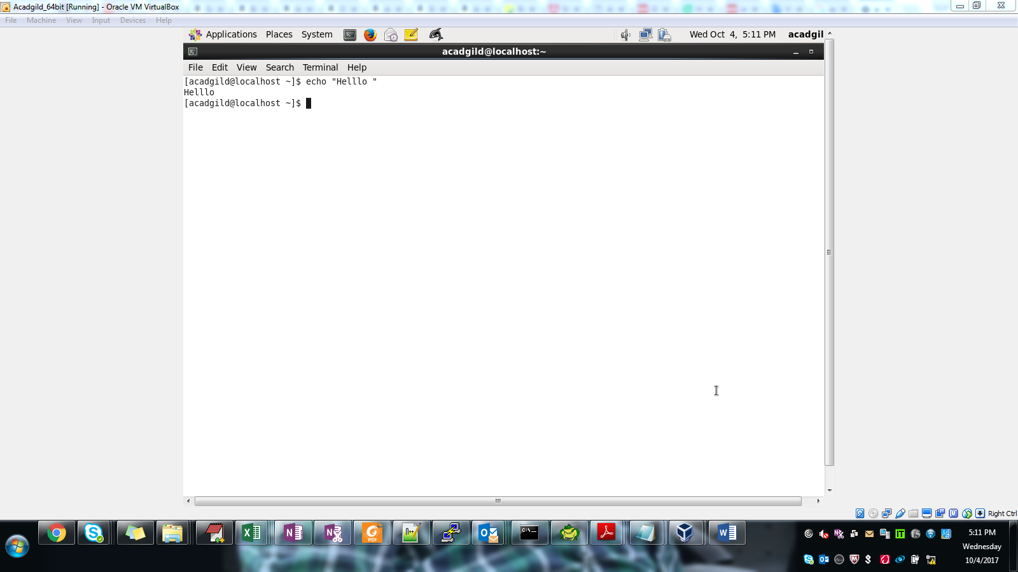

1. cat: Concatenate and print the content of file

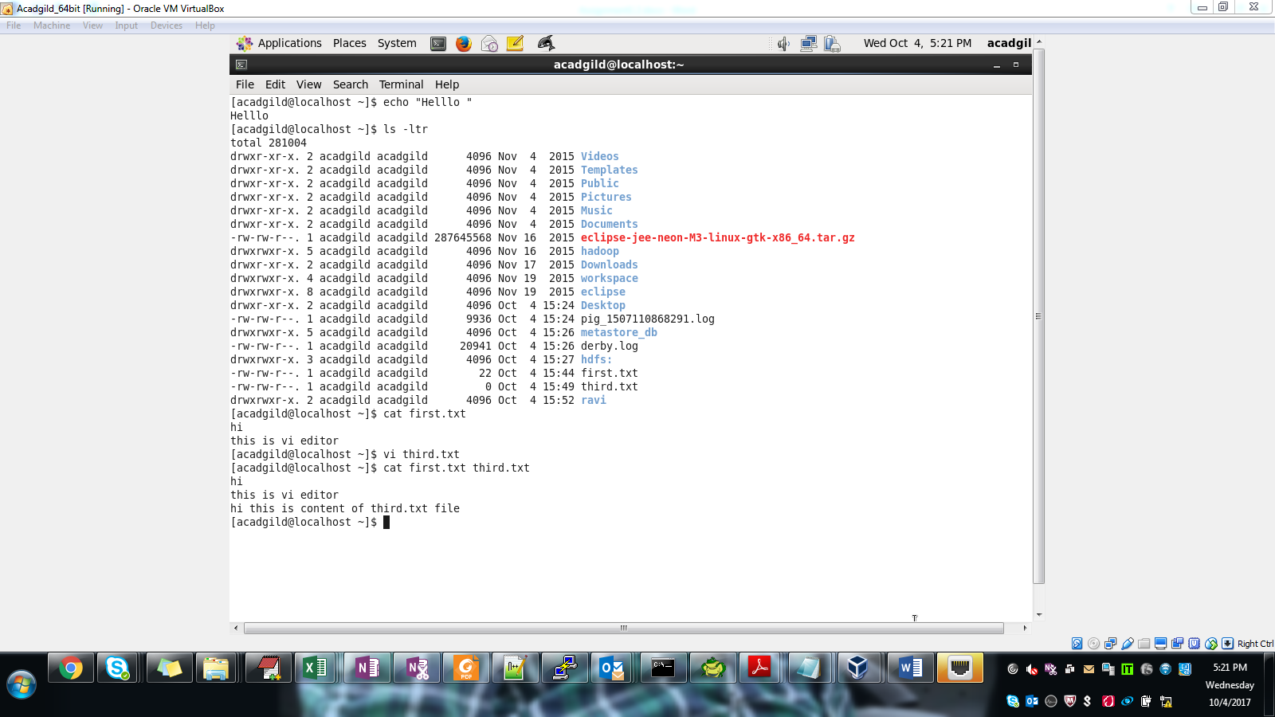

1. who: displays who logged on the system

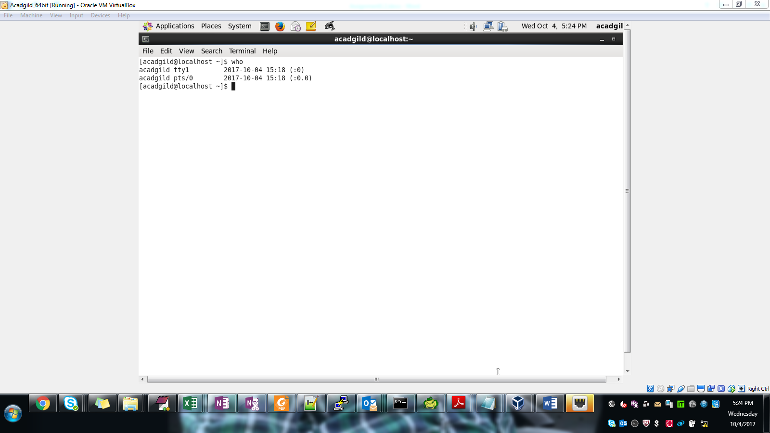

1. cd: to change directory

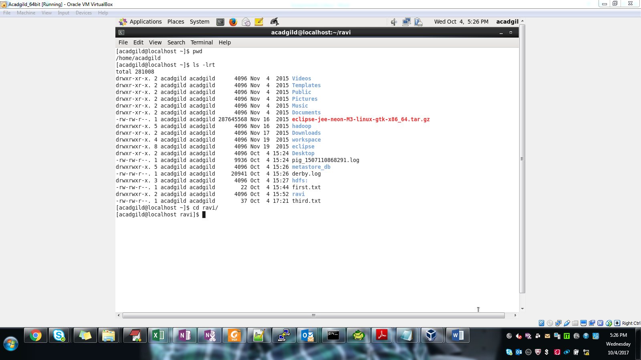

1. date: will show the current date & time of system

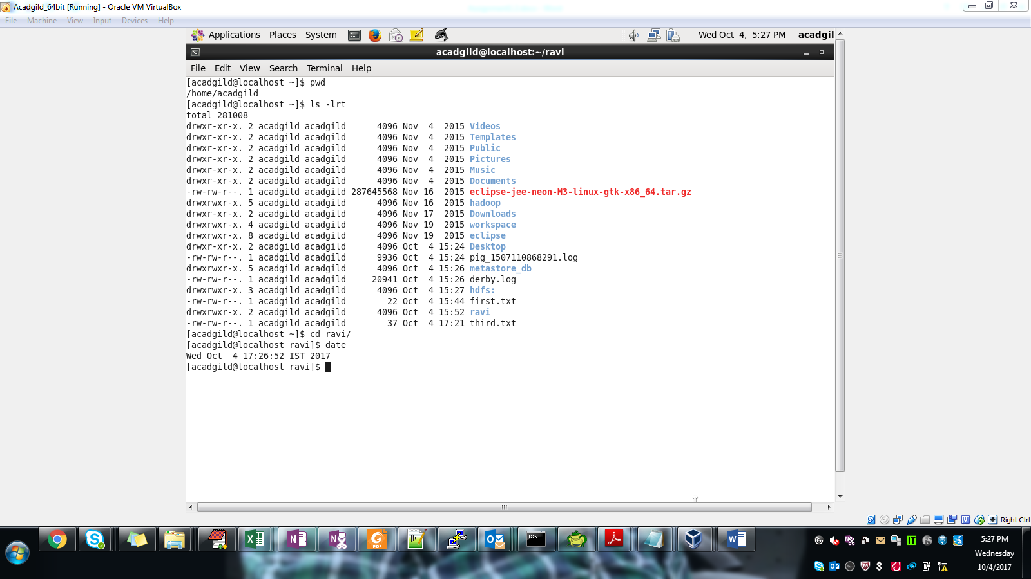

1. cal: will open calender and display current month in screen

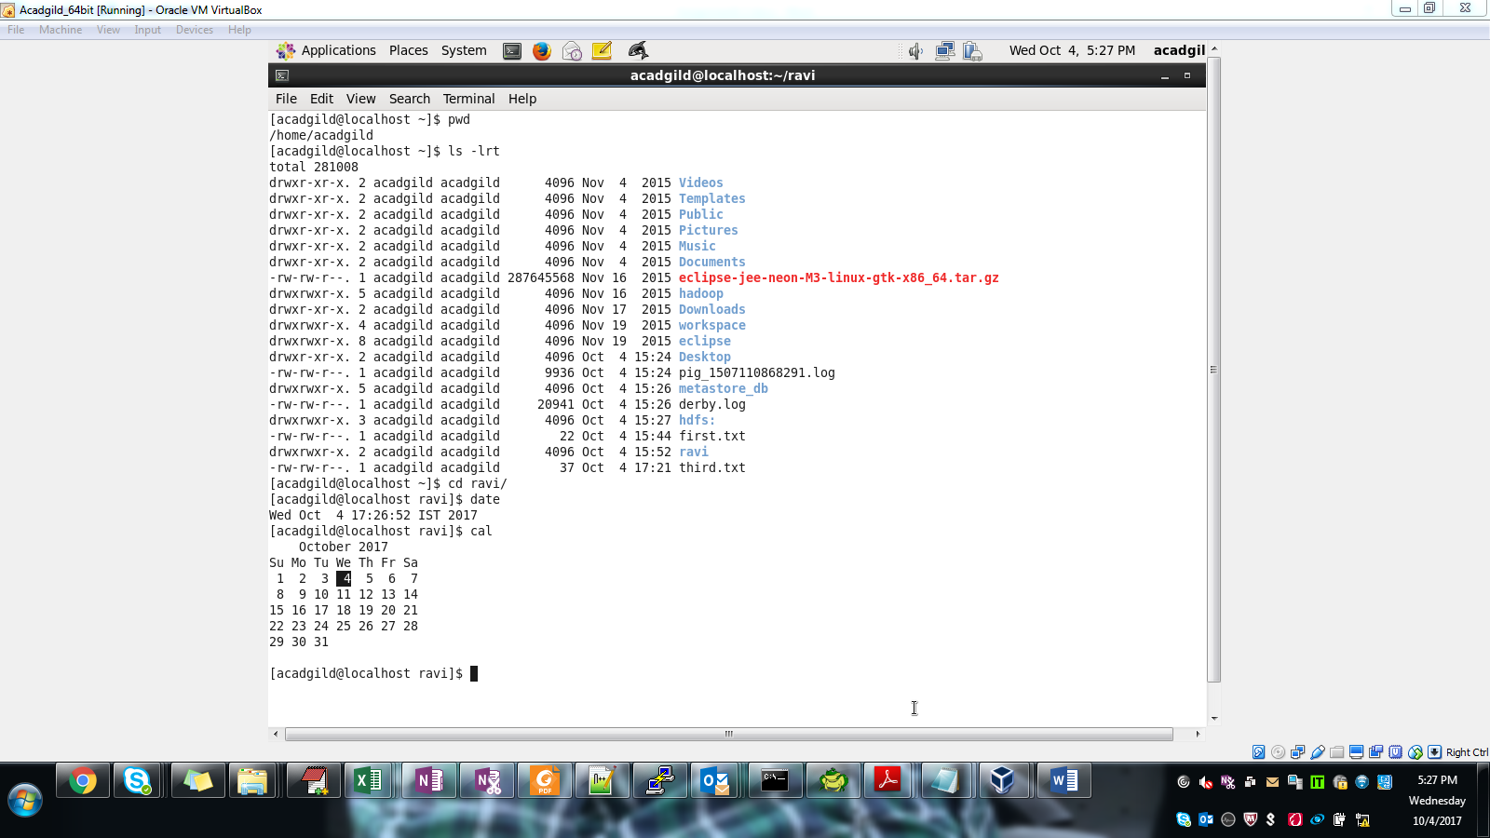

1. mv: rename the file/ folder from oldname to newname

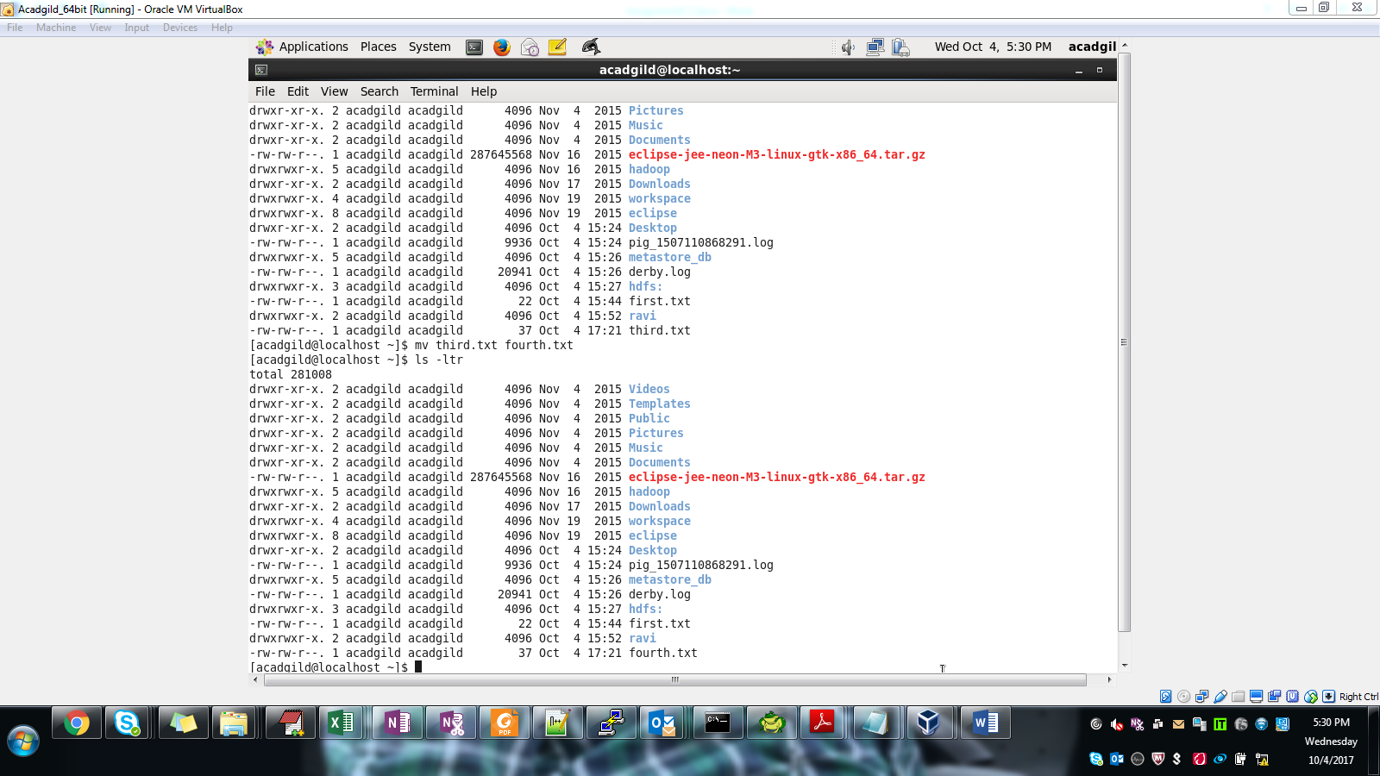

1. cp: will copy content of a file to new filename

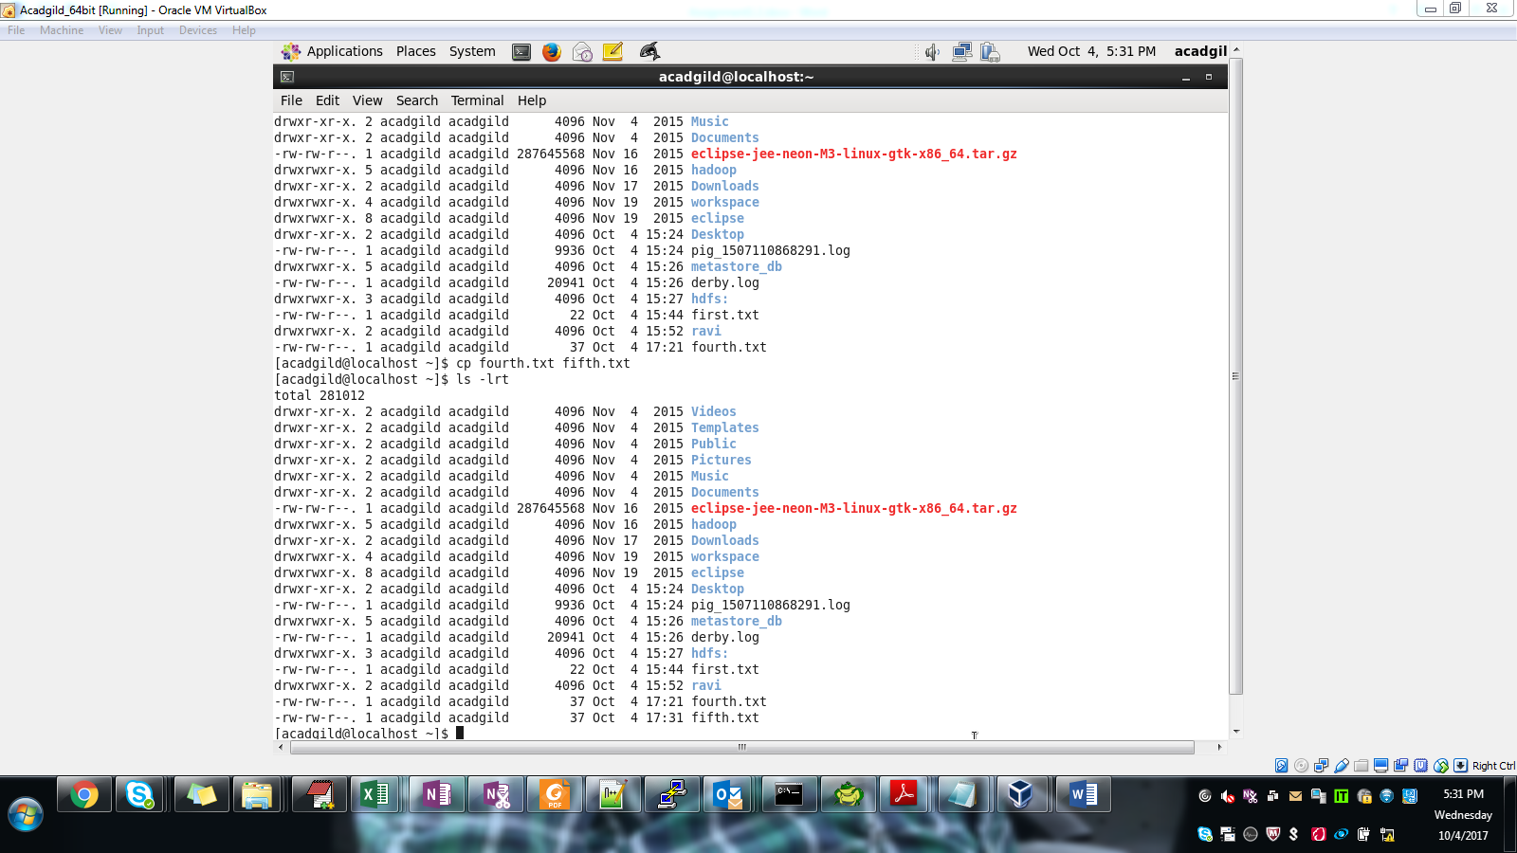

1. which: is used to find the location of the program

